
Miso Full.com
Miso Full is proud to be partnered with Entertainment Max;together serving all of your entertainment needs

THE DELICIOUS DIFERENCE


Miso Full provides traditional and modern solutions to your catering needs. Specializing in intimate affairs of 6 to 60, we offer a wide range of custom menus and selections for any event or occasion.

No matter the size of the gathering, the same conscientious effort is made to renew and re-craft, to astound in looks and flavors.

Food and entertaining is an art. Think of as the affordable pièce de résistance of your party palette.

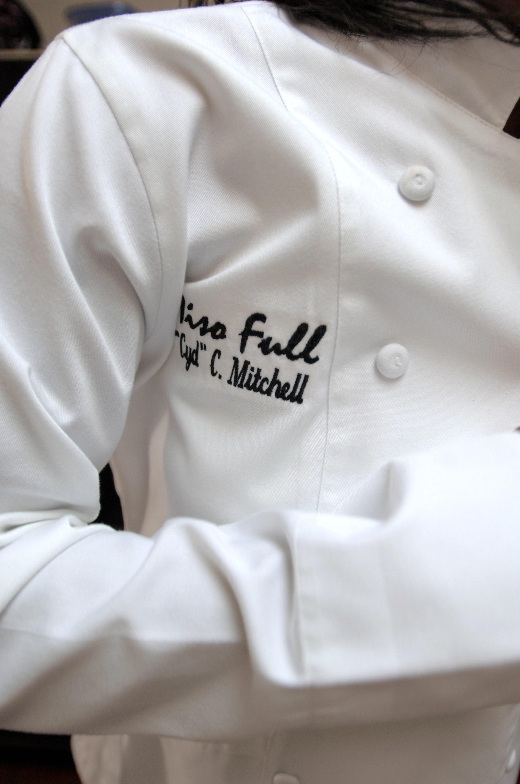
ABOUT US
Miso Full is an independent catering company established in 2007 by founding director Charisse Mitchell who believes that the idea of, and desire for; high quality food, personalized service and stress free entertaining is a not isolated to a select few, nor should it be a privilege exclusive only to the rich and famous.

Great entertaining on any scale can be made available and affordable to anyone.

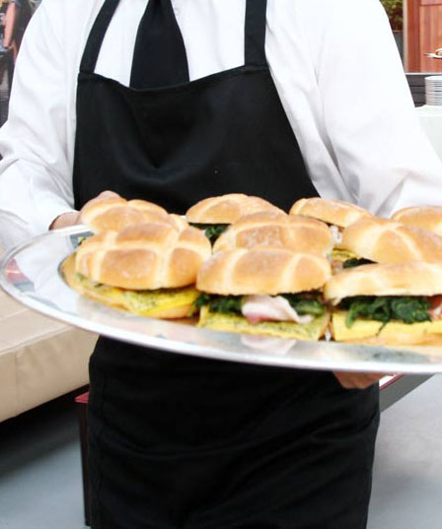
OUR FOOD PHILOSOPY
Simplicity and flexibility are the core principles that influence Miso Full and allows us to provide services tailored to you. We can do as little or as much as required for your occasion.

Every aspect of your menu is conceived, prepared and served by people who love food; creating it, feasting on it and chatting about it endlessly – it is a way of life somewhere between a healthy obsession and a bad habit we can’t shake.

With our professional, experienced and enthusiastic team we are able to offer just about anything that your heart desires.

While our focus is fantastic food, we offer true tailored assistance. Full Service for the far-too-busy, Partial Planning for the hands-on-host and Search and Rescue for the overwhelmed. We are ready to step in at any stage in the planning process. You tell us how much or how little you need then sit back, relax - we'll take it from there.

WE CATER FOOD FOR

Anniversaries
BBQs
Tea Reception
Buffet
Dinners
Luncheons
Brunch
Birthdays
Weddings
Holiday Parties
Theme Parties
Intimate Dinners

WHAT’S THE OCCASSION?


SOIREES & CELEBRATIONS
Whether it’s a wedding, milestone anniversary or birthday, to you it is the single most important day. To us, it’s an opportunity to craft a menu that enhances the experience and exceeds your expectations.


Seated, buffet or cocktails and tray passed canapés, we’ll put the panache into your next party.

INTIMATE ENTERTAINING
There is something truly magical about entertaining at home. It is so sophisticated and elegant yet also very casual, warm and inviting. We bring the restaurant experience home sans the hassle of driving, parking or dividing up the check.

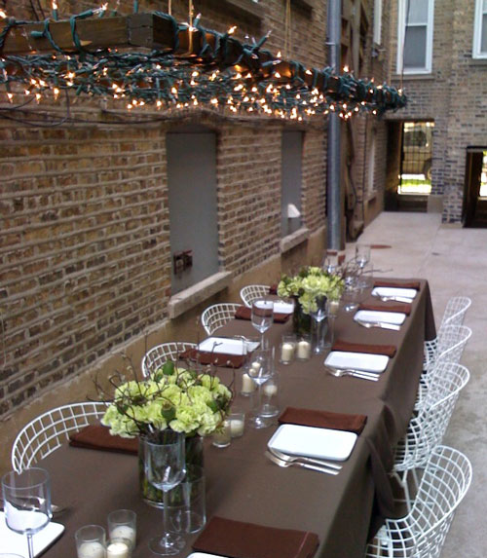
Have no reservations. It is the ultimate in personal dining with the same varied levels of service we provide for larger events but scaled for these more intimate occasions. We can even deliver your meal prepared for you to serve (Sshh, we won’t tell).


Let us create some tasty reasons to throw your next gathering.

CORPORATE CUISINE
If getting down business requires something more than just so-so sustenance, Miso Full can deliver.

Think outside of the brown paper bag and pizza box . Let us create a menu full of variety, flavor and flair for your working lunches, client meetings or office celebrations. We don’t mind a little extra work on our plate.

FOOD FOLIO

Food should be fun, it should be interesting and above all, it should be personal. Want to see what kind of food we can create for your special event? Here is just a small sampling of our vast and varied options.

But remember, the perfect menu does not exist. It is created out of a conversation we have with you.

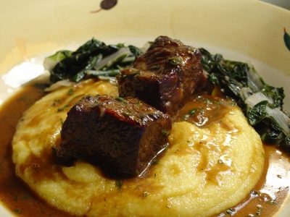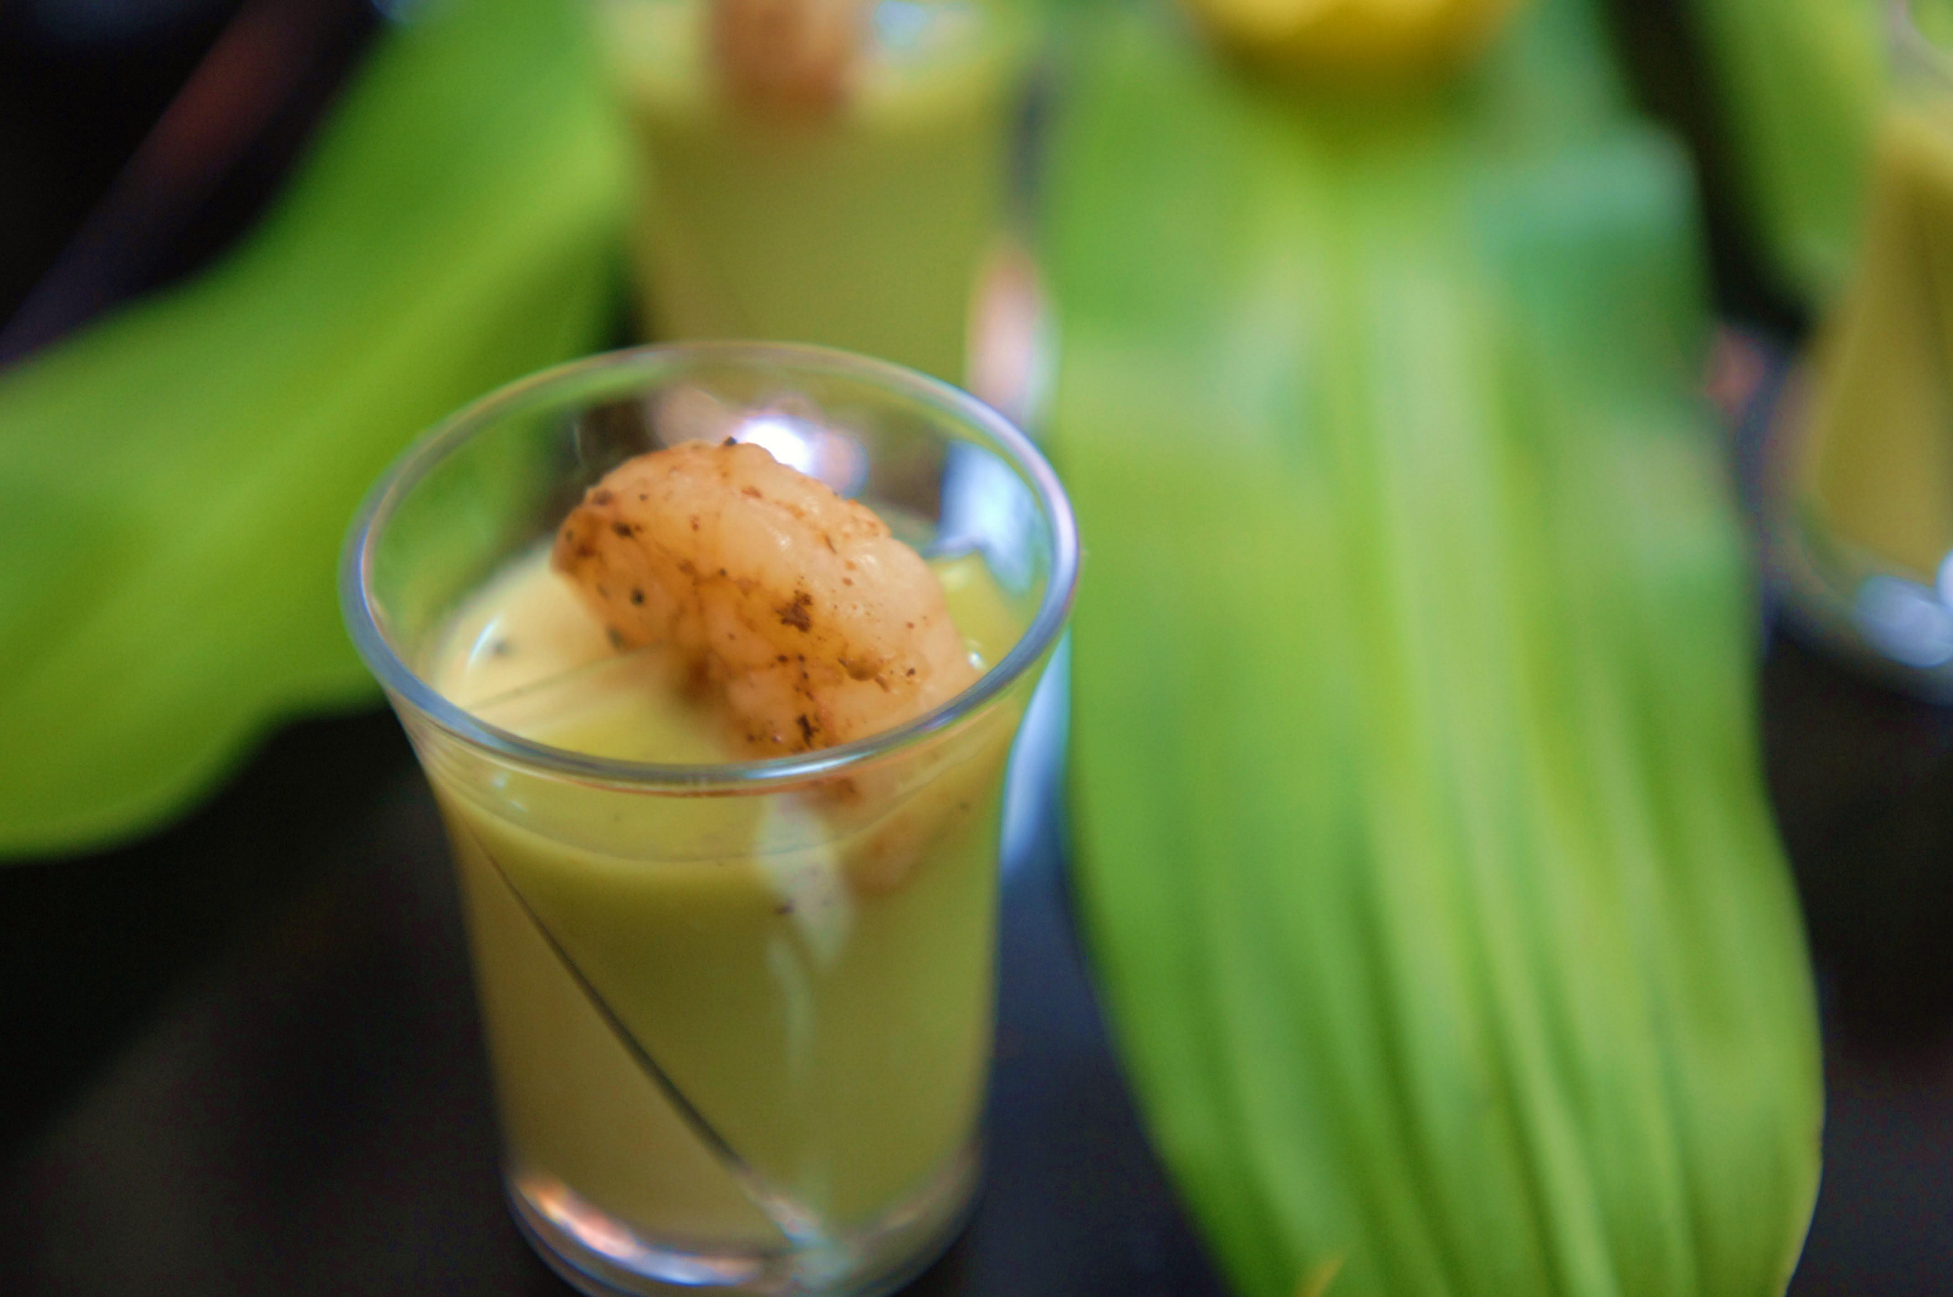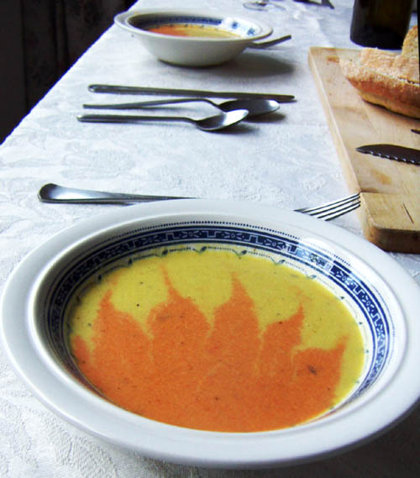

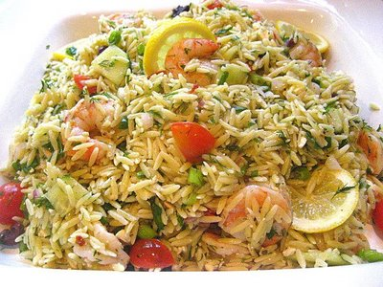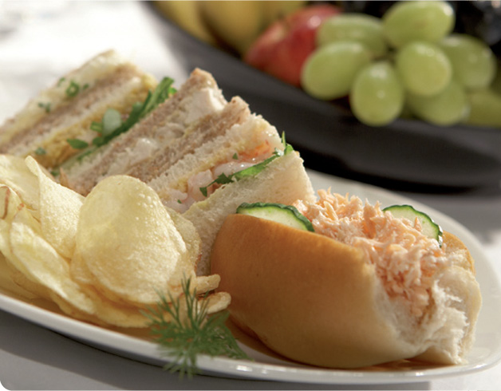

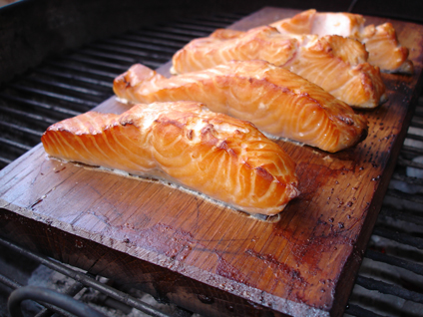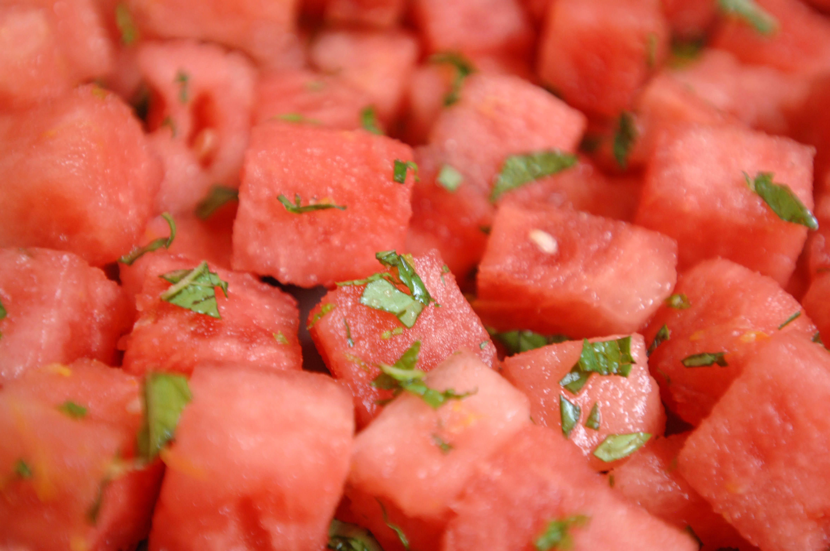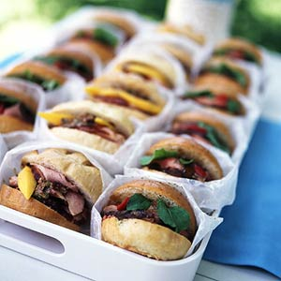

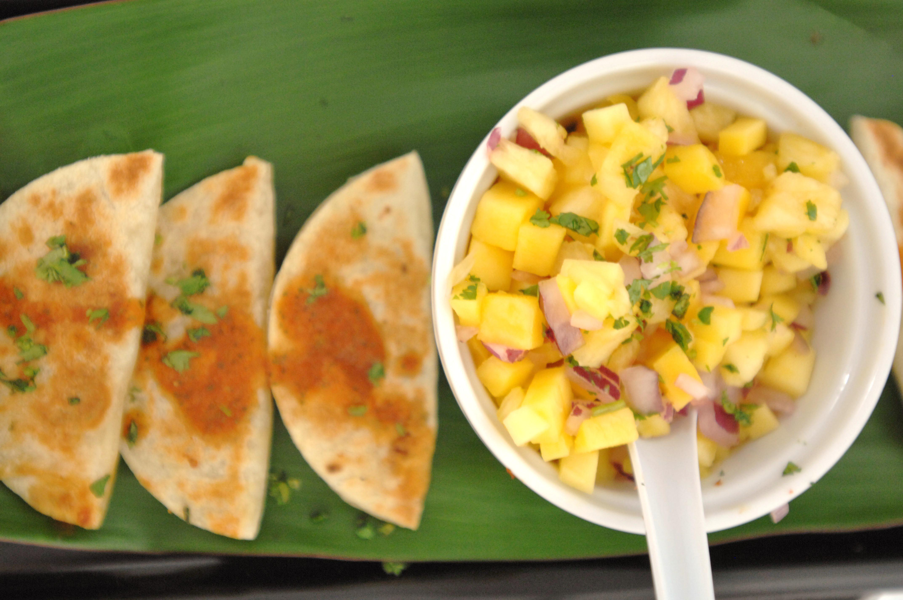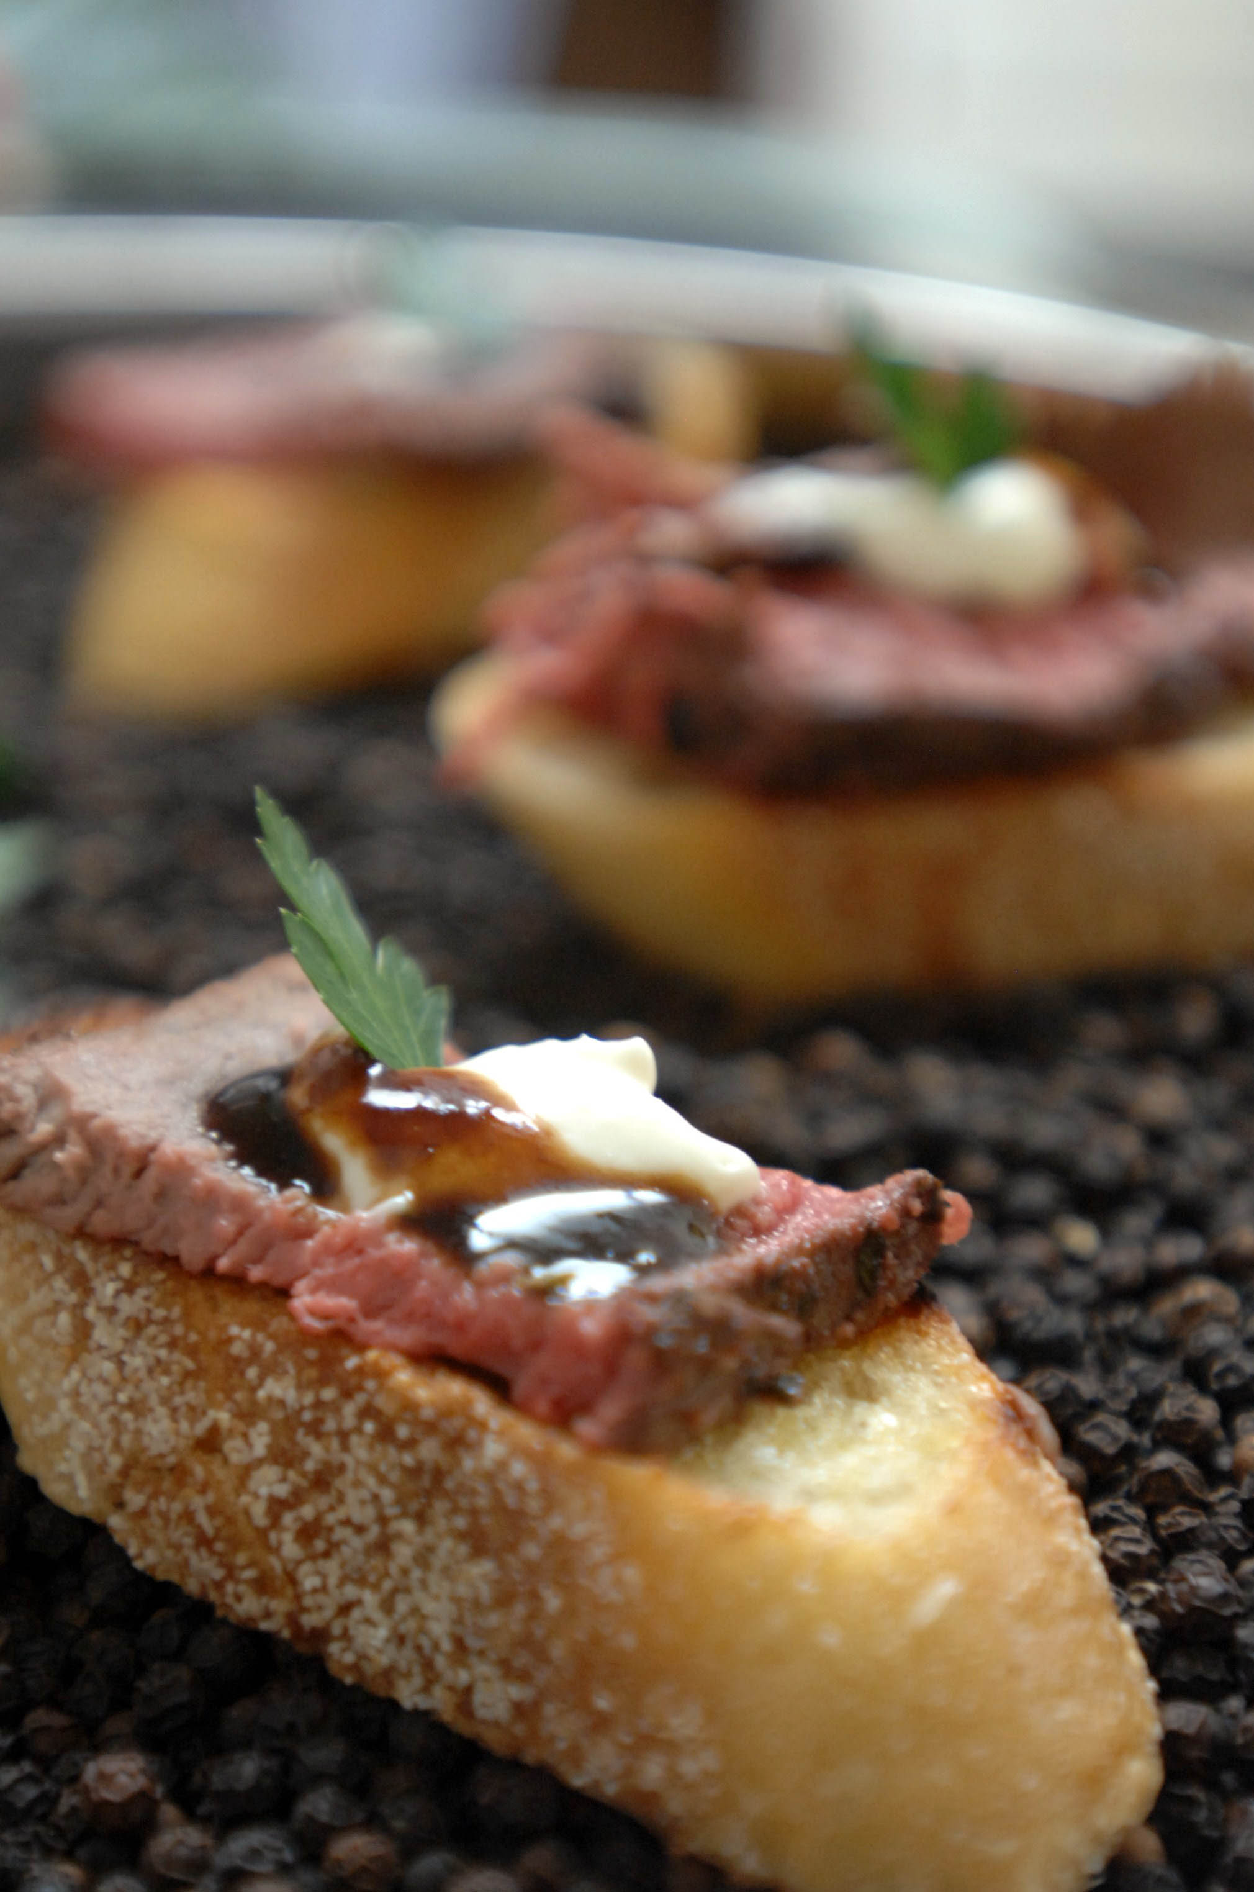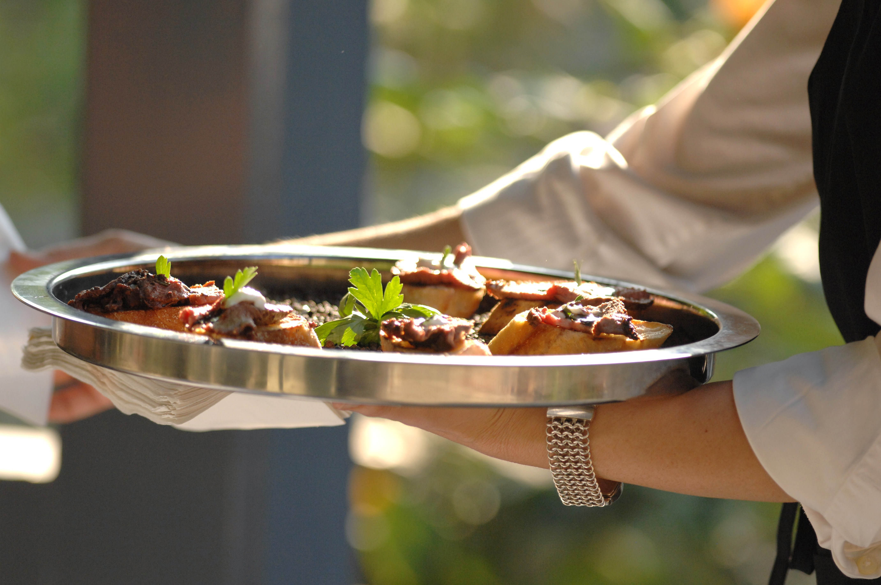

APPETIZERS…
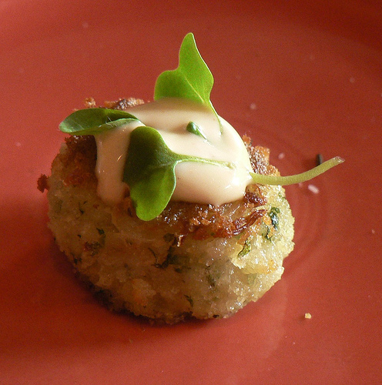
Roasted Squash, Red Pepper, and Jack Cheese Quesadillas with Chipotle Lime Sour Cream
Deep-Fried Mushroom Risotto Bites with a Parmesan & Basil Aioli
“California Roll” Salad on Cucumber Rounds
Char-Grilled Spicy King Prawn with Ginger, Lime and Coriander Salsa
Mini Crab Cakes with Jalapeno or Tarragon Remoulade
Lobster Quesadillas with Cilantro Lime Cream and Pineapple-Mango Relish
Chicken Tandoori Skewers with Yogurt-Mint Dip
Chicken Chilpolte Salad on Grilled Polenta
Grilled Figs in Proscuitto
South by Southeast Roasted Jalapeno Poppers
Spiced Lamb and Apricot Filo Pockets with Mint Yogurt
Pomegranate Lamb Lollipops
Tenderloin Wrapped In Prochiutto on Rosemary Skewers
Pepper-Crusted Steak with Horseradish Cream on Grilled Garlic Crostini

The Minis, Shooters, Sliders, Spoons and Pizzittas

Spoons
Vermouth Scallops with Green Olive Tapenade
Mushroom Purse in Roasted Red Pepper Cream Sauce
Duck with Cucumber, Spring Onion & Hoi Sin

Shooters
Tomato & Basil with Mini Grilled Cheese
Cold Avocado Corn Soup with Cilantro Oil & Spicy Prawn Garnish
Gazpacho with Crab or Cucumber and Crouton Garnish

The Minis, Shooters, Sliders, Spoons and Pizzittas CONTINUED
Minis
Mini Lobster Mac and Cheese
Mini Yorkshire Puddings with Rare Roast Beef
Mini Steak Sandwiches with Anchovies & Dijon Mustard Relish

Pizzittas
Truffled Taleggio and Mushroom
Smoked Salmon with Crème Fraiche and Caviar
Manchu Spiced Garlic Chicken with Hoisin
Little Mississippi Pulled Pork Pizzittas

Sliders
Mini Baby Bella with Piquillo Pepper Aïoli
“21” Club Sliders
Lobster Rolls
Fresh Salmon with Tarragon-Lemon Aioli

INTIMATE DINING

Starters
Watermelon Salad with Feta, Toasted Almonds and fresh Herbs
Honey-Roasted Pear Salad with Toasted Hazelnuts, Dried Cranberries and Thyme Verjus Dressing
Roasted Yellow Pepper Soup and Roasted Tomato Soup with Serrano Cream
Avocado Ahi Tuna Tartar Tower
Firecracker Spinach Salad with Orange Sesame Dressing
Roasted Butternut Squash and Caramelized Onion Tart
Scallop Ceviche with "Tiger's Milk"
Creamy Wild Mushroom Soup with a Crusted Brie Kebab
Salads… (see BUFFETS)

Main Course
Grilled Apricot-Mustard Salmon on Confetti Orzo Pilaf
Roasted Red Pepper and Scallop Fettuccine
Grilled Chicken Breast with White Rosemary Barbecue Sauce and Potato and Pea Salad with Chive Aïoli
Breast of Chicken stuffed with Spinach, Garlic and Wild Mushrooms with Three-Potato Gratin
Roast Leg of Lamb with Tarragon-Mint Butter, Garlic Mashed Potatoes and a Garland of Spring Vegetables
Braised Lamb with Minted Red Cabbage with a Wild Mushroom Brandy Sauce
Fillet of Beef sautéed in Red Wine served with Honey Glazed Carrots, Garlic & Chive Mash, topped with a Red Onion Marmalade and Barolo Jus
Short Ribs Braised in Coffee Ancho Chile Sauce served with Creamy Corn-Studded Polenta and Sautéed Broccolini
Pork Tenderloin with Caramelized Pears and Pear-Brandy Cream Sauce

Vegetarian Main Courses
Grilled Portobello Burgers with Piquillo Pepper Aïoli and Watercress
Creamy Chablis, Zucchinis & Wild Mushroom Risotto drizzled with Saffron Oil
Goat Cheese Ravioli with Bell Peppers and Brown Butter
Wild Rice and Brown Rice Cakes with Roasted Vegetable Ragù
Individual Root Vegetable and Mushroom Pie with Rosemary Biscuit Topping

LUNCHEONS

Sandwiches
Market Pita Sandwich
Black Bean and Vegetable Wraps
Caprese Sub
Cheese-Filled Eggplant Sandwiches with Pomegranate Molasses (breadless)
Grilled Cheese with Onion Jam, Taleggio, and Escarole
The B.L.A.—Bagel with Lox and Avocado
Tuscan Tuna Sandwiches
New England Crab Rolls
Chicken Gyros with Cucumber Salsa and Tsatsiki
Warm Chicken Sandwiches with Mushrooms, Spinach and Cheese
Chicken Breast with Caramelized Onions, Watercress, and Paprika Aïoli
Vietnamese Chicken Sandwich (Banh Mi)
Chipotle Chicken Salad
Smoked Turkey, Blue Cheese, and Red Onion Sandwiches
Smoked Turkey Wraps with Mango and Curried Mayonnaise
Sausage, Arugula, and Piquillo Pepper Sandwiches
Bacon, Egg, and Tomato Club Sandwiches
Grilled Ham and Gouda Sandwiches with Frisée and Caramelized Onions
Italian Stuffed Sandwich
Roast Beef with Lemon-Basil Mayo
Pepper-Crusted Beef and Arugula with Spicy Mustard and balsamic

Salads
Minted Watermelon Salad
Pineapple, Honeydew, and Mango with Ginger and Fresh Herbs
Mesclun Salad
Mixed Field Greens with Tomatoes and Balsamic Vinaigrette Dressing
South by Southwest Caesar Salad
Endive and Apple Salad
Spicy Napa Cabbage Slaw with Cilantro Dressing
Herbed Potato
Confetti Orzo

BUFFETS

Salads
Italian Tri-Color Pasta Salad with Olives, Cherry Tomatoes and Feta Cheese
Oriental Noodle Salad with Water Chestnuts & Hoi Sin Sauce Dressing
Asparagus and Fresh Strawberry Salad with a Light Raspberry Vvinaigrette
Wild Rice, Pineapple and Cashew Nut Slad
Classic Caesar or Pasta Caesar Salad
Mixed Green Leaf Salad with Your Choice of Dressing
Gazpachio Salad
Classic, Crunchy Coleslaw Salad
New Potato Salad with Creamy Mayonnaise and Chopped Chives
Soba Noodles with Garlic Broccoli Florets and Sweet Soy, Ginger and Chilli Dressing
Red Leaf Lettuce with Crispy Prosciutto, Gorgonzola and Honey Mustard Dressing
Roast Vegetable Salad with Pesto Dressing

Cold/Tempered
Alder Smoked Salmon with a Cucumber, Sliced Potato, Asparagus and Dill Salad
Blackened Salmon and Cucumber Salad with a hint of Chilli and a Coconut Milk and Lime Dressing
Seared Tuna Fillet with White Bean Salad, Cherry Tomatoes and Capers
Char-Grilled Chicken Caesar Salad with Romaine & Parmesan Shavings
Vietnamese Chicken Salad with Shredded Carrot, Cabbage and Mint
Seared Beef, Red Onion, Marinated Mushroom and Roquefort Salad
Thai Style Beef Salad, Bok Choy, Cucumber and Spring Onion with a Palm Sugar Dressing
Sticky Roast Duck, Mango, Spring Onion and Mixed Greens with a Honey, Ginger and Soy Dressing
Lamb Fillets with a Sesame, Tamarind and Palm Sugar Chutney on a bed of Cous Cous

BUFFETS CONTINUED

Hot
Spicy Shrimp with Andouille Sausage with Pepper Spiked Parmesan Polenta
Prawns, Chorizo and Sage Skewers, Roast Vegetable Cous Cous, Sweet Tomato and Red Onion Sauce
Cedar Planked Maple-Soy Salmon with Wasabi Mashed Potatoes
Moroccan Salmon Baked in Foil with Minted Yogurt and Basmati Rice
Crab Cakes with a Sweet Corn Relish and Parsnip Mash
Braised Chicken with Cider, Whole Grain Mustard, Rosemary and Cream Sauce
Cinnamon Scented Sweet and Sour Braised Chicken and Pepper Spiked Parmesan Polenta
Chicken, Asparagus and Truffle Risotto with fresh Parmesan Cheese and Arugula
Chicken Stuffed with Fontina, Parsley and Sage, in a reduced lemon and thyme Lyonnaise
Deconstructed Holiday Turkey with Sage Gravy, Rosemary Roasted Vegetables and Cauliflower Purée
Shredded Hoi Sin Glazed Duck with Fine Noodles
Guinness braised Beef with Mushrooms and Shallots served with Herbed Mashed Potatoes
Cabernet Braised Short Ribs with Parmesan Mashed Potatoes
Spiced Coconut Lamb with Yoghurt and Cream served with Basmati Rice
Chargrilled Yogurt Marinated Lamb Skewers on Roast Onion Pilaf with Pine Nuts

Vegetarian
Roasted Mediterranean Vegetables Lasagna with Pesto and Toasted Pine Nuts
Penne Pasta with Sun-Blushed Tomatoes, Roasted Sweet Peppers and Shaved Parmesan
Rigatoni with Asparagus, Wilted Arugula, Peas, White Beans and Truffle Oil
Creamy fig pasta with gorgonzola, cream and lemon
Tempura Vegetables, Soba Noodle Salad, Smoked Chilli Dressing
Lasagne of Mediterranean Vegetables
Gougère with baby spring vegetables, light Fontina cheese sauce and herb butter
Thai Style Vegetable Curry with Scented Rice

